**Cell Profiler – Making a Basic Segmentation Project and Exporting a Pipeline**

Date: 11/11/2024

# 0. Before we start:

## 0.1. What this guide is for

This guide will give you a step-by-step tutorial to build a basic Cell Profiler project that segments images and saves their segmentations, as well as how to export that project to a pipeline. Cell Profiler is an extremely powerful toolkit for cell image analysis and comes with tons of features, so this guide will try to get you started but barely scratches the surface of what is possible. Cell Profiler becomes even more powerful when paired with tools like Ilastik, as we will discuss here, making the options for how to process your data almost endless.

Read on to learn how to make your own Cell Profiler image segmentation project and how to export it as a pipeline!

## 0.2. What is used in this document

* [Cell Profiler](https://cellprofiler.org/): An application for cell image analysis.
* Any image of a format that is compatible with Cell Profiler (we will use tiff images)

## 0.3. Helpful resources

* [Cell Profiler Official Documentation](https://cellprofiler-manual.s3.amazonaws.com/CellProfiler-4.2.8/index.html)
* [Cell Profiler Examples page](https://cellprofiler.org/examples) a page with examples of Cell Profiler applied in various contexts to inspire your next project.
* [Cell Profiler Forums](https://forum.image.sc/tag/cellprofiler) a public forum of all things Cell Profiler
* [Cell Profiler Beginner Segmentation Tutorial](https://tutorials.cellprofiler.org/#beginner-segmentation) a tutorial showing human cell segmentation

## 0.4. Tips

* When running a project, toggle the eyeball button in the module workflow area to turn on/off preview output from each module. Having it on can be helpful when fine-tuning settings, however, for large projects displaying output from each module can be annoying.

# Building a Cell Profiler Segmentation Project:

## 1.0. Starting a Cell Profiler Project

Upon first opening Cell Profiler, you will be greeted with a screen similar to:

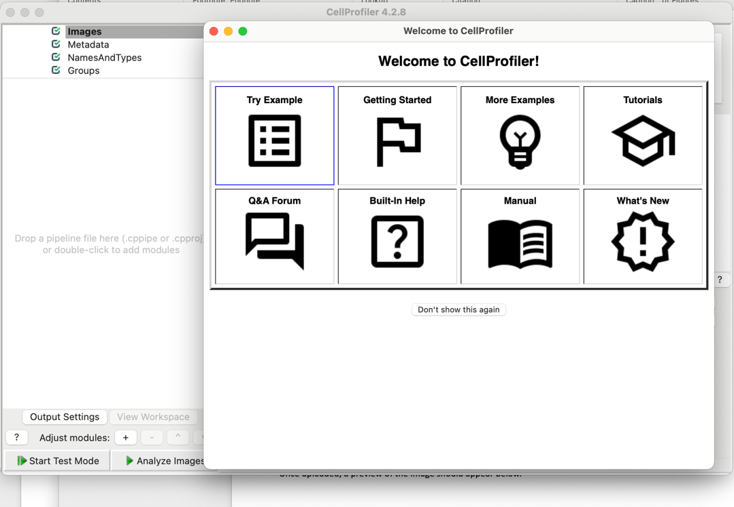

You may close the “Welcome to CellProfiler” popup, however, it is a very useful resource so don’t forget it is there! After closing this we will only see the project screen and are ready to begin building our project!

## 1.1. Preprocessing

### 1.1.1. Preprocessing - Uploading Images

In the “Images” step we will can drag and drop the data we want to use in this project. For now we will use three images for display purposes:

* A combined two channel image of neuronal mitochondria, with mitochondria marked with TMRE, and DNA marker with Sybr.
* The probability map output of an Ilastik Classifier trained to recognize mitochondria from the TMRE channel.
* The probability map output of an Ilastik Classifier trained to recognize mtDNA from the Sybr channel.

Each of these images are displayed below, in order.

Drag these into the area that says “Drop files and folders here”, it should now look something like:

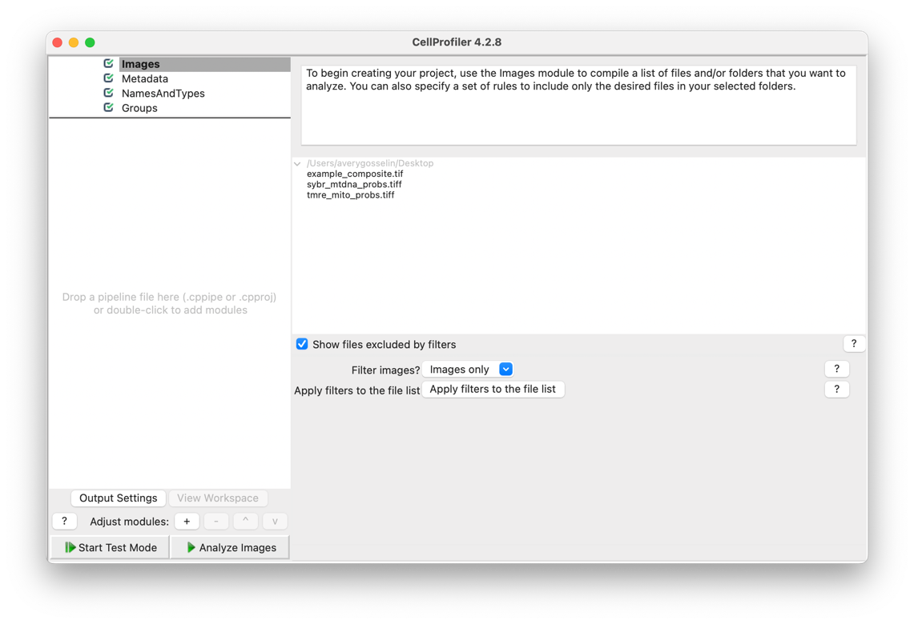

### 1.1.2. Preprocessing - Defining NamesAndTypes Metadata

Next we will go to the “NamesAndTypes” step (skipping “Metadata”, which, while useful, is not necessary for this basic workflow. This window is where you will assign meaning in Cell Profiler to the images you have uploaded. While our use case is very simple, this window can be extremely powerful so take some time to explore your options. The default window for this appears as:

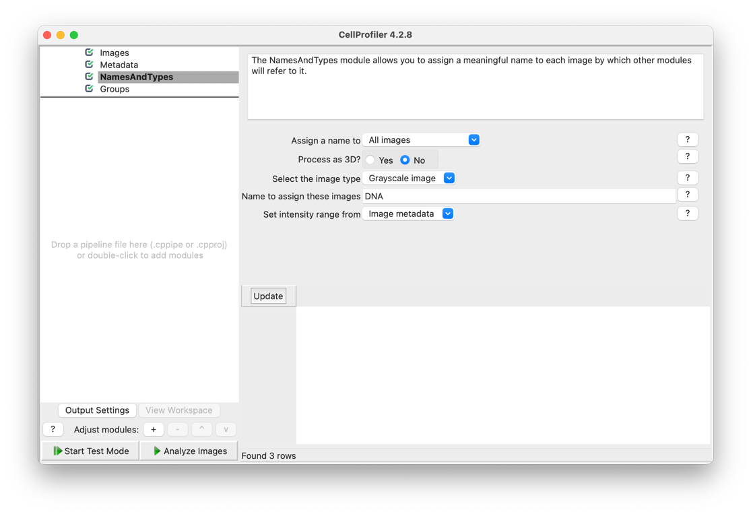

We will now add rules to define our 3 image classes in the NamesAndTypes settings:

#### 1.1.2.1. Defining the Composite Image Class

Begin by setting the “Assign a name to” dropdown to “Images matching rules”. This will alter the interface slightly to add a field where you can assign a ruleset your image must match to be a part of this class.

Here we will set the newly displayed “Select the rule criteria” to: File + Does + Contain + “composite”, and then the “Name to assign these images” to “Composite”. Then set “Select image type” to “Color image”, as this image is RGB. This searches through our uploaded files and returns all where the file does contain the keyword “composite” and places them in a class called “Composite”.

Now press the “Add another image” button to add our next class.

#### 1.1.2.2. Defining the Mito Image Class

Now set the “Select the rule criteria” to: File + Does + Contain + “mito”, and then the “Name to assign these images” to “Mito”. This does the same as the previous step but instead groups the mitochondria probability map images.

Now press the “Add another image” button to add our next class.

#### 1.1.2.3. Defining the mtDNA Image Class

Now set the “Select the rule criteria” to: File + Does + Contain + “mtdna”, and then the “Name to assign these images” to “mtDNA”. This does the same as the previous step but instead groups the mtDNA probability map images.

Now by pressing the “Update” button below, you should see a chart containing our data grouped by these class names:

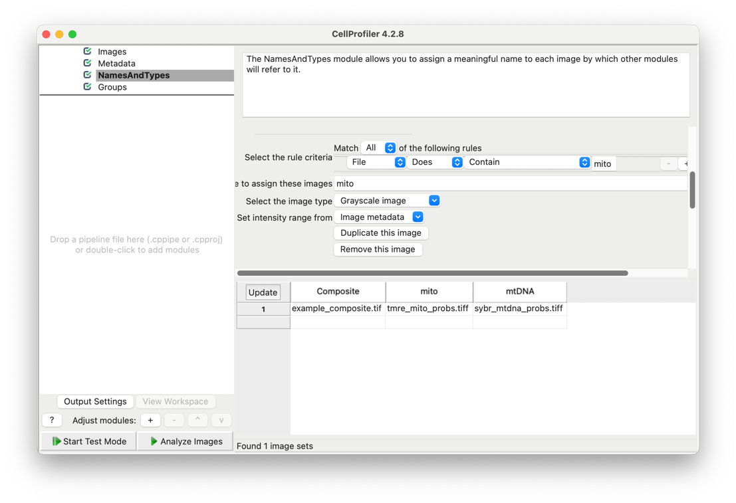

We will skip the “Groups” step and now get right in to building our segmentation project!

## 1.3. Segmentation - Adding an IdentifyPrimaryObjects Step to Identify Mitochondria

To build projects in Cell Profiler we use a series of modules dedicated to specific steps. One of these modules, called IdentifyPrimaryObjects can be used to perform instance segmentation (identifying distinct objects in a shared class). Here, we will use it on our mitochondrial probability map images in the “Mito” class we just defined to identify individual mitochondria in the image.

### 1.3.1. Adding the IdentifyPrimaryObjects module

To add this module, begin by pressing the “+” button in the bottom left of the screen, next to where it says “Adjust modules”. This should display the “Add Modules” panel:

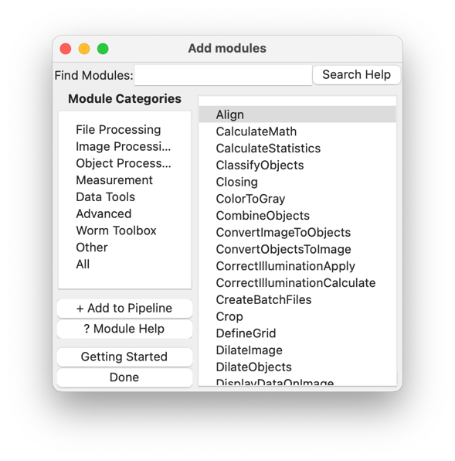

In the search bar, type “IdentifyPrimaryObjects”, then double click to add the module. This should add it to our project and we may now get to work configuring it!

### 1.3.2. Configuring the IdentifyPrimaryObjects module

Now that we have added the module, we need to configure and tune it to actually identify our mitochondria objects. By default, the settings should look like this:

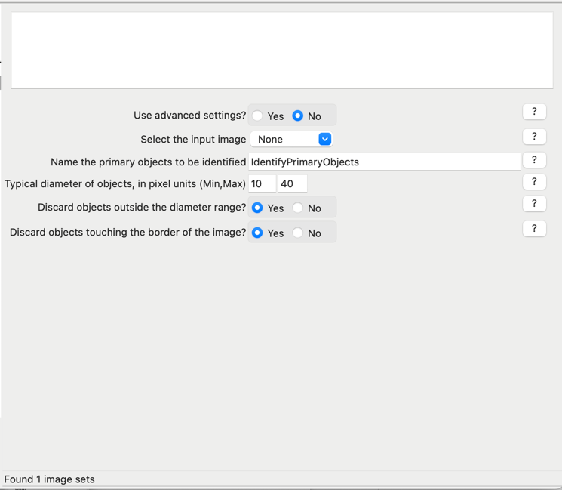

To make this work on our mitochondria images, set “Select the input image” to “Mito”, and “Name the primary objects to be identified” to “Mitochondria”.

We can now get a sense for how well our settings work by pressing the “Start test mode” button in the bottom left of Cell Profiler and then “Step” to run this module. This should display an output window showing the result of IdentifyPrimaryObjects:

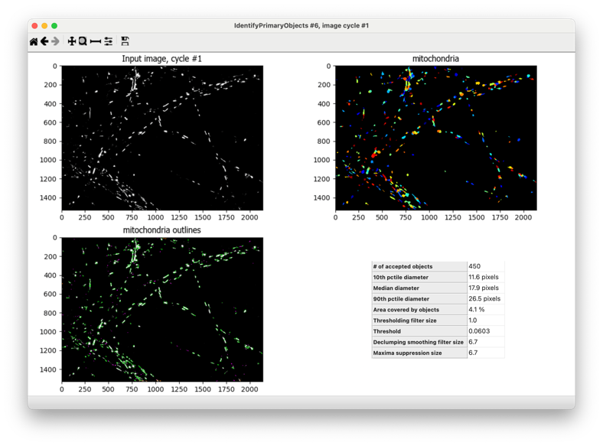

After a closer look using the analysis tools Cell Profiler gives us in the top left of this viewer, however, we see that this is not a particularly good segmentation. Unfortunately, segmentation is a rather difficult problem, and so we will need to spend some time fin-tuning our settings to suit our data.

### 1.3.3. Configuring the IdentifyPrimaryObjects module with advanced settings

Start by setting “Used advanced settings” in the module’s settings to “Yes”. The window should update to display much more granular settings options.

To avoid getting into the specifics of what each of these settings does (which you can come to understand through the help buttons next to each and good old-fashioned trial and error) feel free to copy the settings below that appear to work fairly well for demonstration purposes with the image used in this example. Note that you may need to modify these if you are using different images.

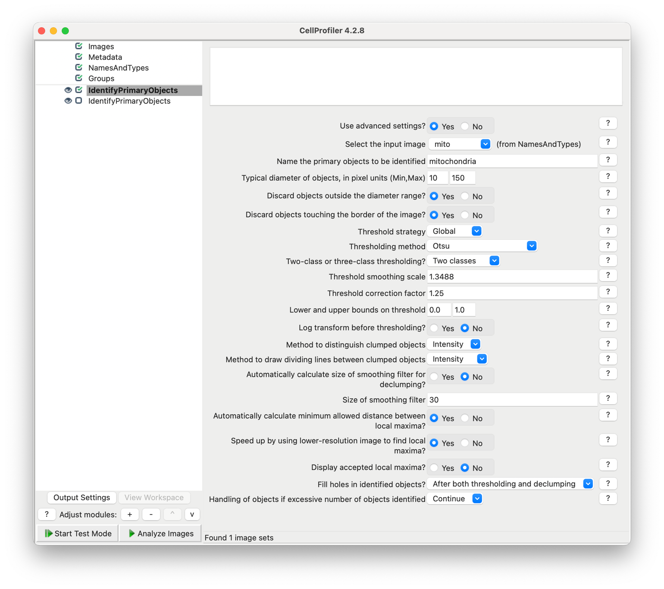

Running test mode on this image now yields much better results, and we may continue with identifying mtDNA.

## 1.4. Segmentation - Adding an IdentifyPrimaryObjects Step to Identify mtDNA

We will now repeat the previous step to segment the mtDNA in our mtDNA class images.

Begin by adding another IdentifyPrimaryObjects module to your workflow, whether it comes before or after the previous is irrelevant.

### 1.4.1. Configuring the IdentifyPrimaryObjects module with advanced settings

We will again set “Use advanced settings” to “Yes”. Next, set “Select the input image” to “mtDNA” and “Name the primary objects to be identified” to “mtDNA”. The remainder of the settings can be set as follows:

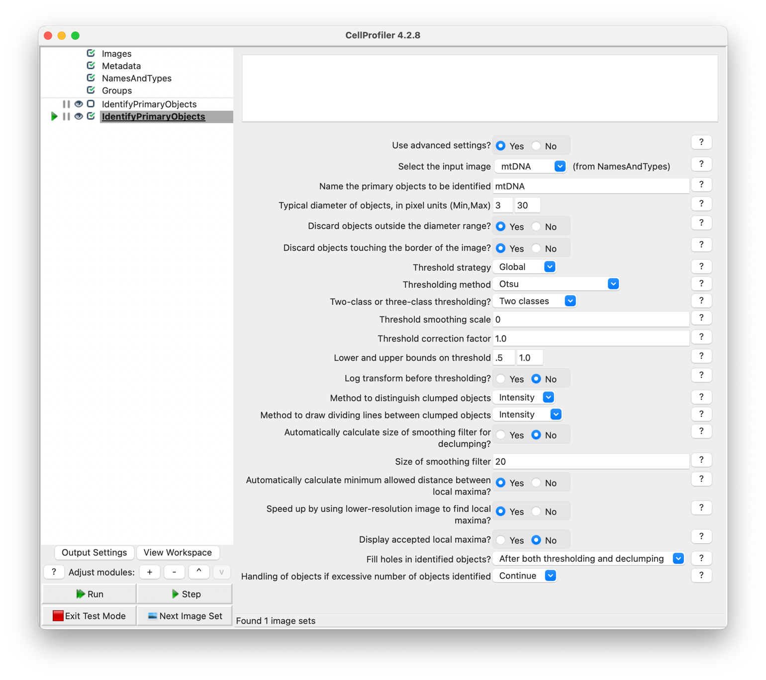

One powerful feature of note here is the typical diameter of objects setting. This setting is very useful in suppressing noise in our data by placing an acceptable range for how large objects can be. For example, in this case the mtDNA typically range from very small specks taking up just a few pixels to somewhat larger assemblies of 20-30 pixels. However, there are also artifacts that are smaller (single pixel) and large clumps of over 50 pixels from background noise and nucleic DNA we do not want to classify! However, thanks to this setting, we are able to filter these and get segmentations like the following:

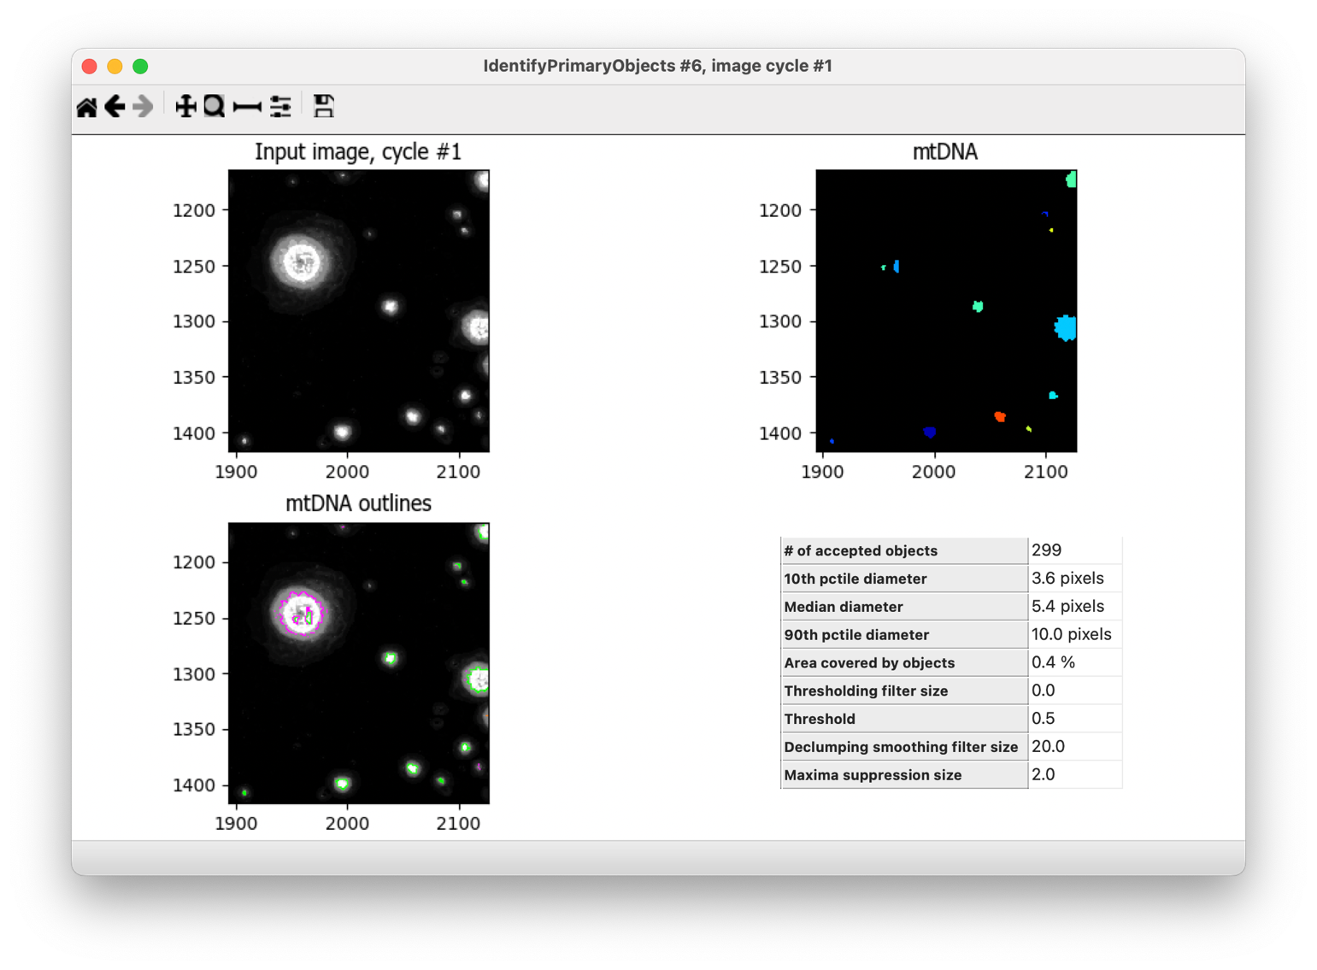

Note how the large blob that is likely not typical mtDNA is filtered out of our results.

We will now move on to saving this segmentation overlaid onto our original composite image.

## 1.5. Building our Output Image - OverlayOutlines

We begin by adding an OverlayOutlines module after both IdentifyPrimaryObjects. OverlayOutlines is particularly useful for displaying the result of segmentations or other object processing steps onto other images to validate and display results in a user-friendly way, which is exactly how we will use it here.

This will display the module with the default settings:

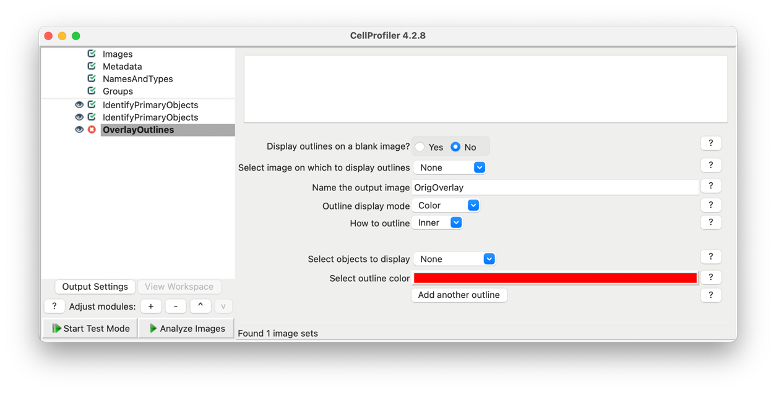

Set “Select image on which to display outlines” to “Composite” (the raw, channel merged image we added earlier) and name it “segmentation_output”.

Next set “Select objects to display” to “mitochondria” and select the outline color of your choice, just making sure it will be visible when shown over the original input image. In this case, we will use yellow.

Next, press “Add another outline” and configure this new outline to display the mtDNA, setting the “Select objects to display” to “mtDNA” and, again, the outline color to a color of your choice, we will use blue.

Now when we enter test mode and step through each of these modules, we will see the object outlines overlaid on our composite image!

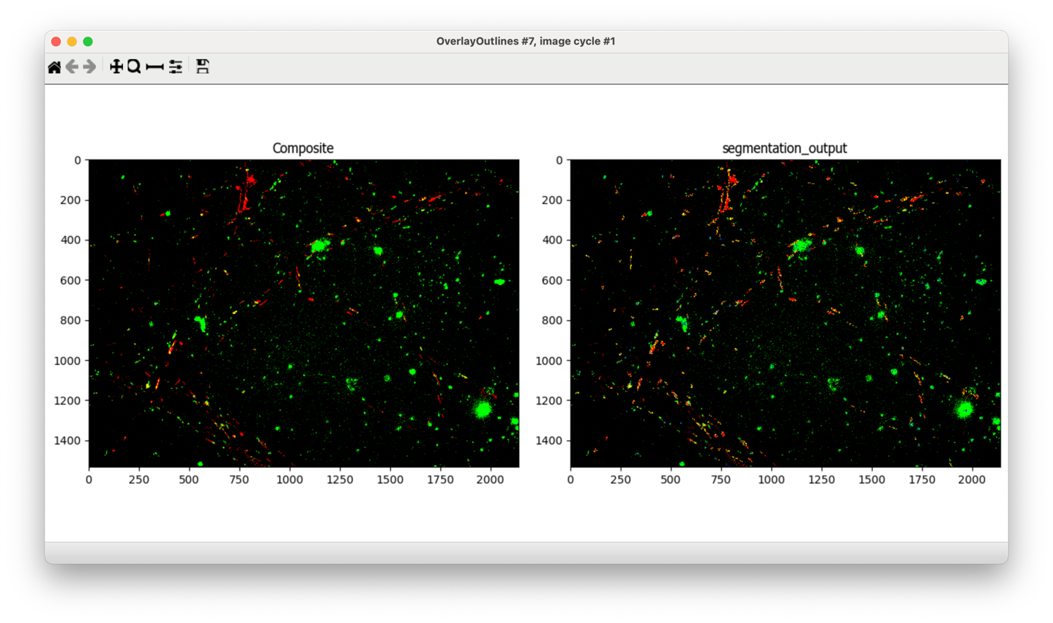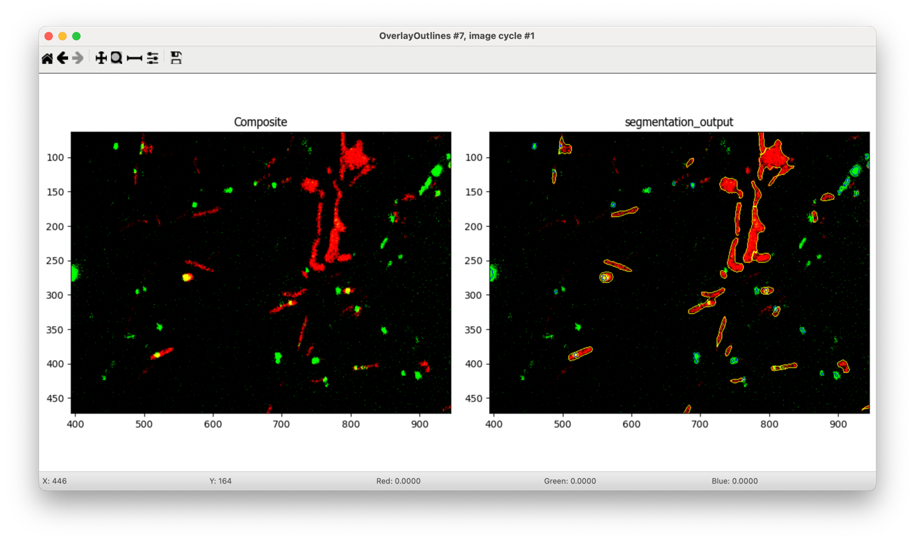

### 1.5.1. Saving our Output Image - SaveImages

Lastly, we will save our output image (“segmentation_output”) with the SaveImages module.

Add a SaveImages module to the end of the workflow with the Adjust modules “+” button. Here, the only settings we need set now are:

* “Select the image to save” to “segmentation_output”.
* “Select image name for file prefix” to “Composite”
* “Output file location” to whatever directory you want to save your output data to.

After doing this, our module structure should look like the image below, and we are ready to run it! 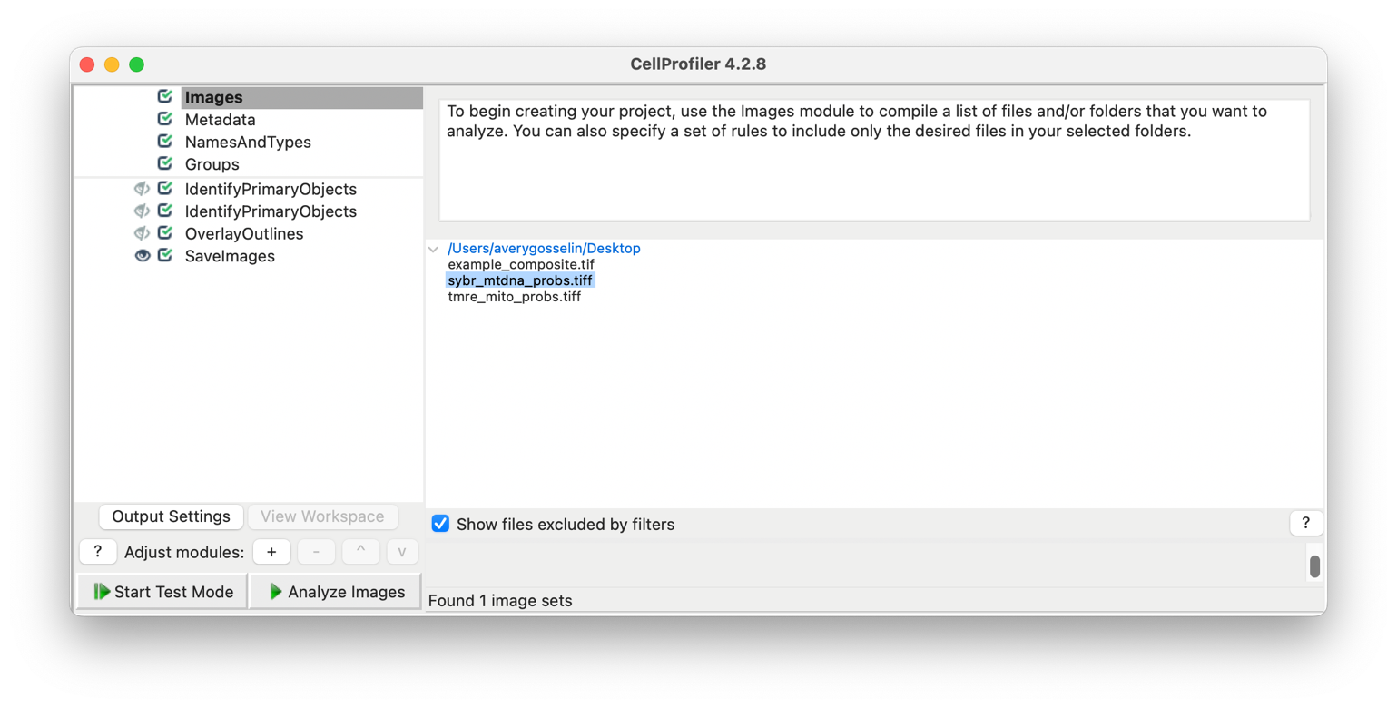

## 1.6. Running a Project

While the test mode is useful when configuring a project, we do not want to have to step through each module every time we use this. Instead, to run everything all at once, press “Analyze Images”, Cell Profiler will then automatically run through your entire workflow, and should save the output image in the location defined in “SaveImages”!

## 1.7. Postscript

Now your project is fully set up! From here you may want to continue adding new modules to suit your needs, or you can try adding larger datasets to your input. While in this example we only used one image processed in different ways, it is likely you will have larger sets of images. To batch process these you need to just ensure that your NamesAndTypes can still group them properly and that they come with identifiers so they can be associated. For example, if you had two images from the microscope named “example001” and “example002”, your input folder may look like:

* example001_composite
* sybr_mitos_001_probs
* tmre_mitos_001_probs
* example002_composite
* sybr_mitos_002_probs
* tmre_mitos_002_probs

In this case, the NamesAndTypes we defined earlier will handle this perfectly, and running the project will yield two output images. Making sure that your data is structured in a way that it can be properly organized in Cell Profiler is one of the most crucial steps in building these projects!

# Exporting a Project to a Pipeline

After finalizing your project, you may want to export it to a Cell Profiler pipeline file rather than a project file. The key difference being, the *project* is both the set of images you load into the workflow as well as the series of modules that comprise your data processing steps. The *pipeline,* however, is only the series of processing steps, and exists independently of any set of images, making them easy to share and automate for batch processing.

To export a pipeline from a project all you must do is:

1. Open the project in Cell Profiler
2. File -> Export -> Pipeline
3. Define what your pipeline will be named and where to save it

Just like that you have exported the pipeline file and can use it in automated workflows like ImageFlow!